**SQL**

1. By selecting *, this shows all the fields and records in table

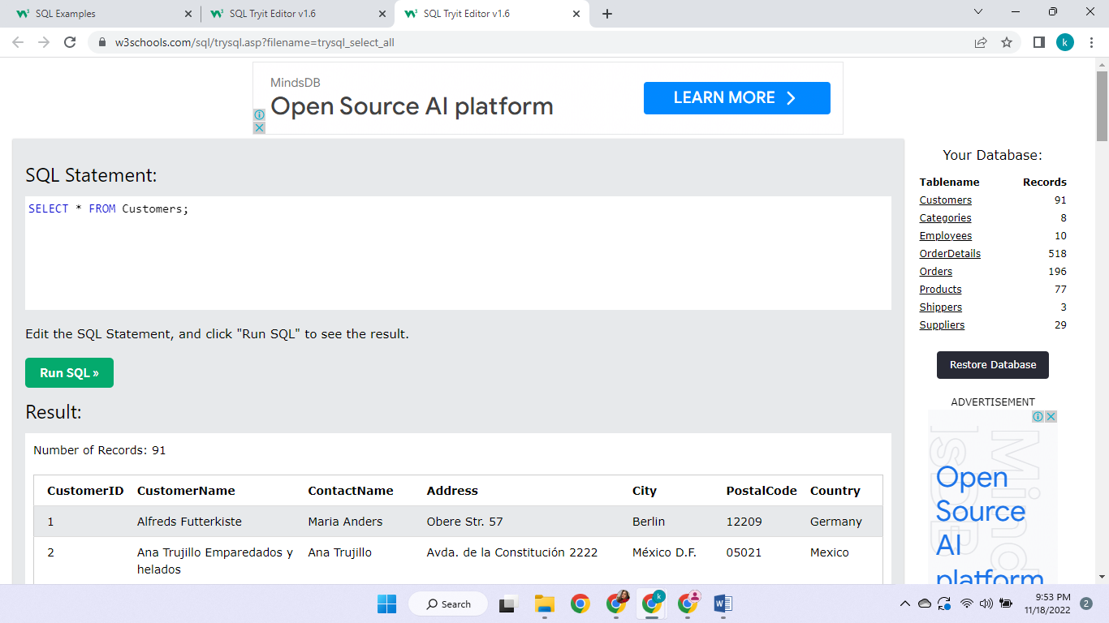

1. This displays only the selected columns of the table

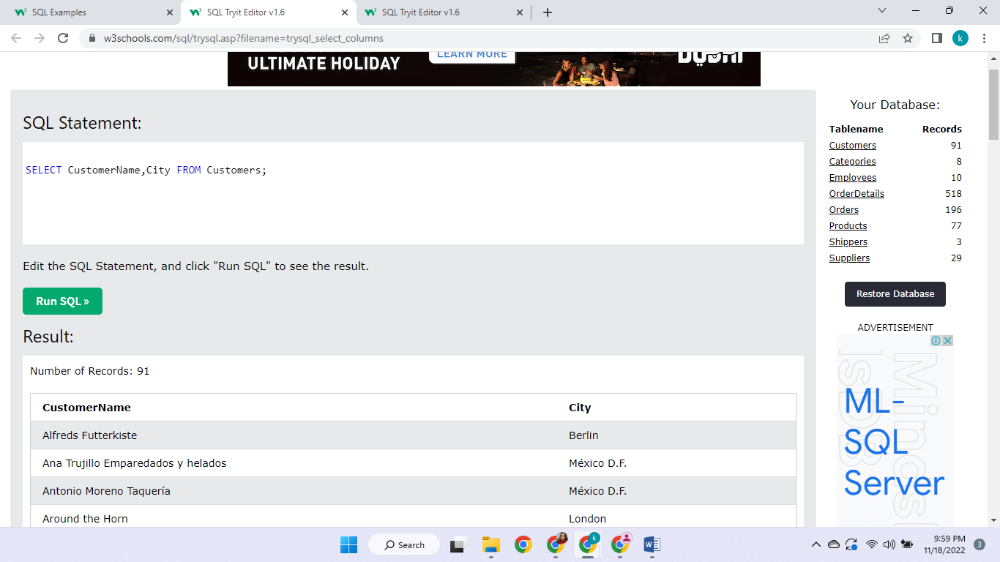

1. This is showing all the countries’ name just once or displaying all the different entries

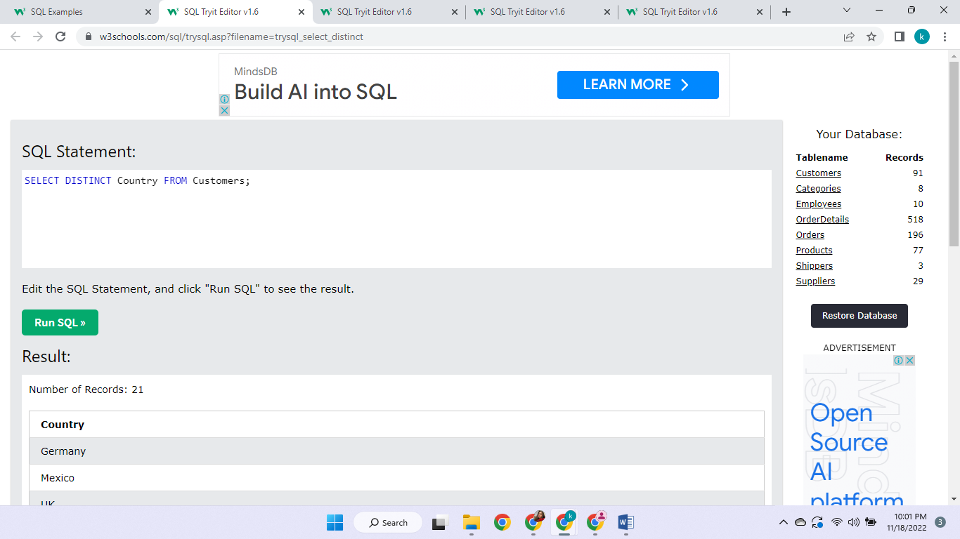

4.This is showing the number of all the countries listed

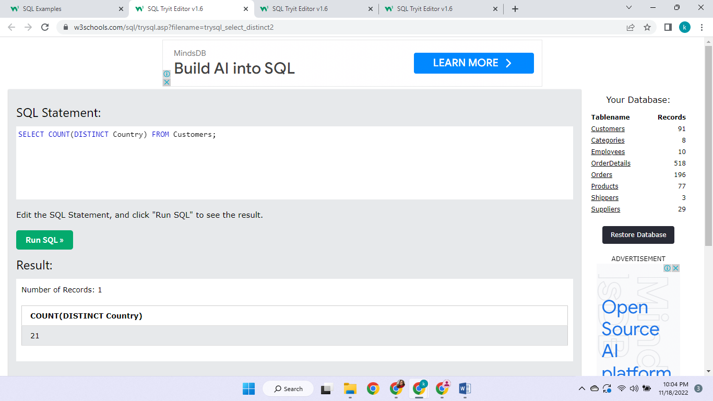

5. This is showing all the records related to mexico

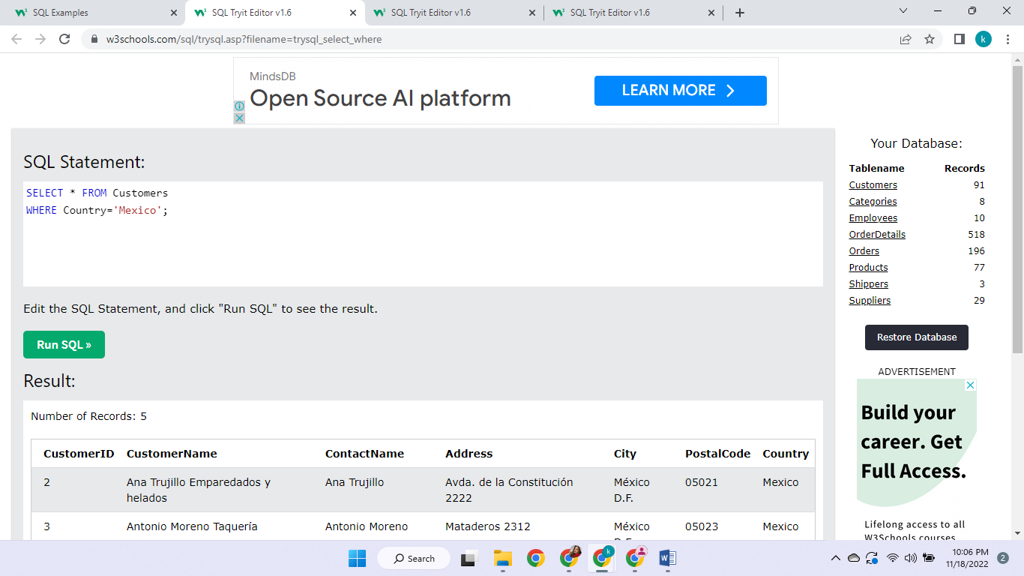

1. This is showing that record with customer id 1 (unique)

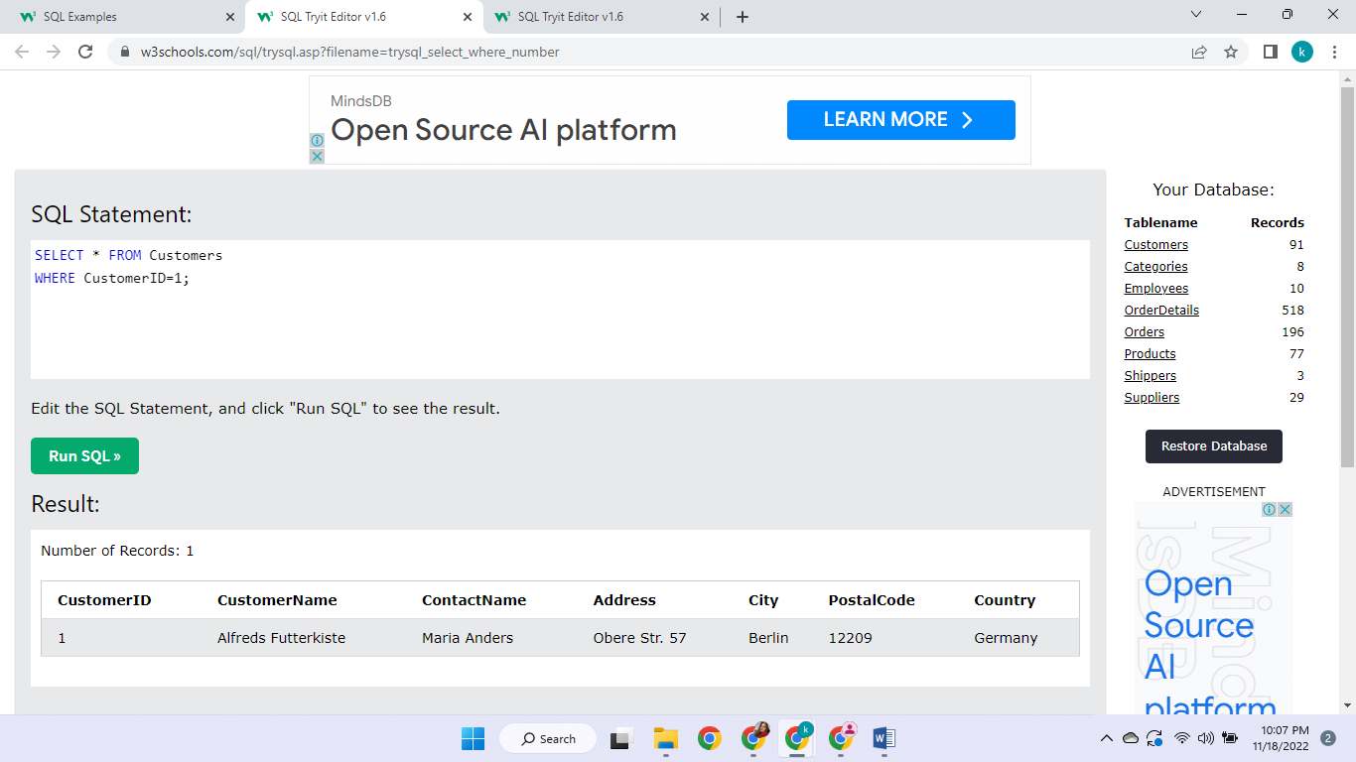

7. This is displaying records that have country selected: Germany AND city selected: Berlin

For this, both the conditions should be met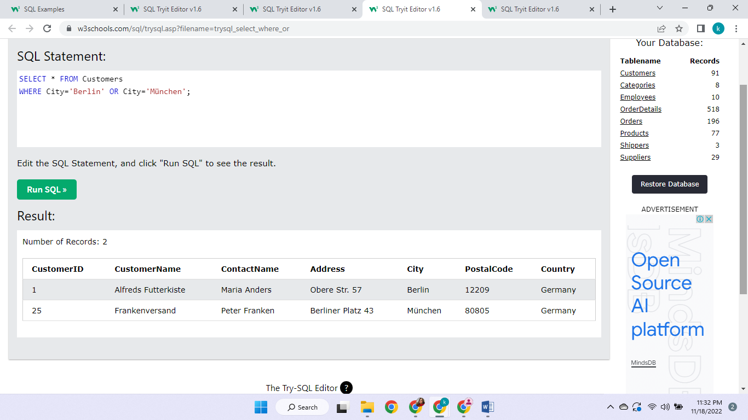

8. This is displaying records that have city selected: München OR city selected: Berlin

For this, any of the condition should be met



9. This is selecting all the records except for that one in which the country is Germany

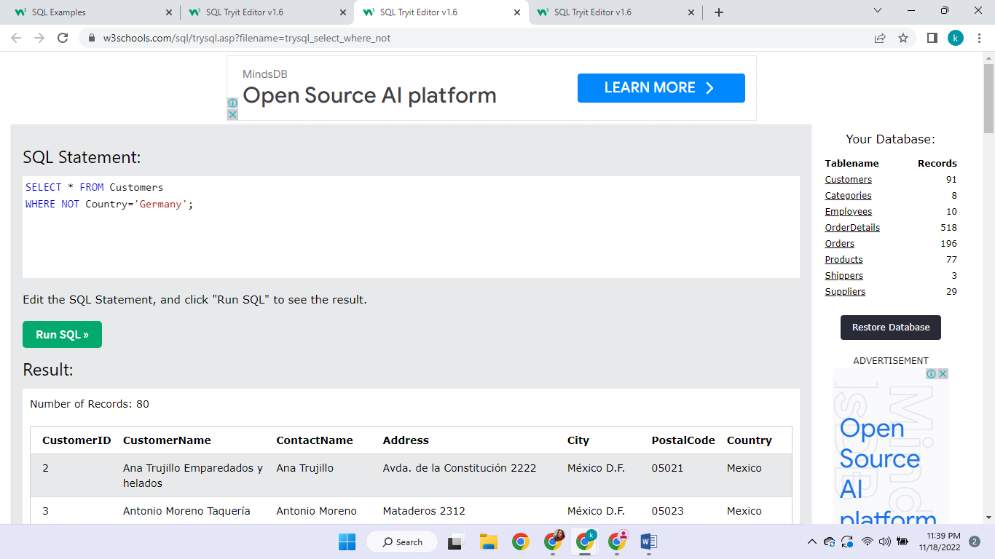

10.This is a combination of AND and OR

The country selected should be Germany AND

Either the city is Berlin or it can be München

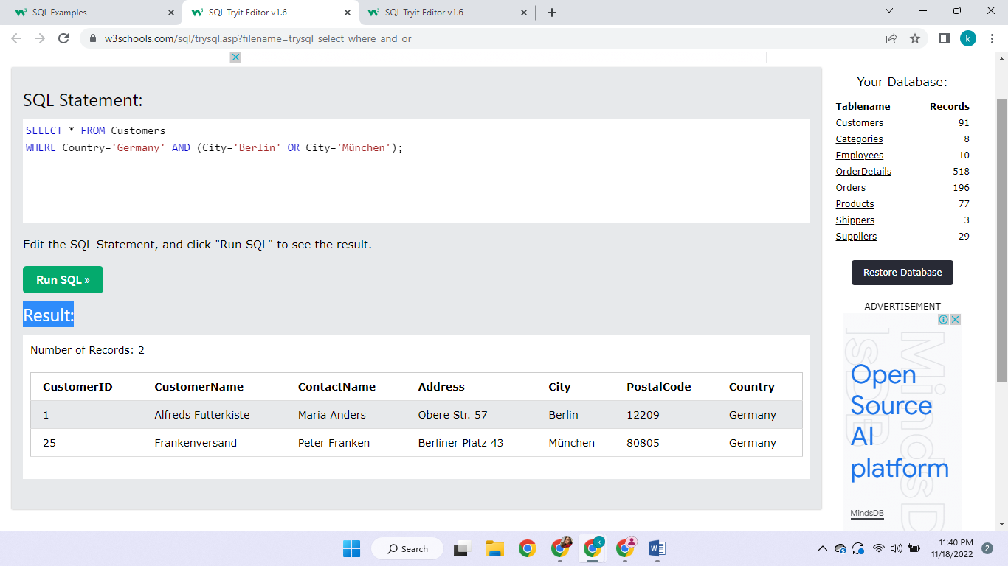

11. This is listing the records in a way that the countries’ name is in alphabetical order (A to Z)

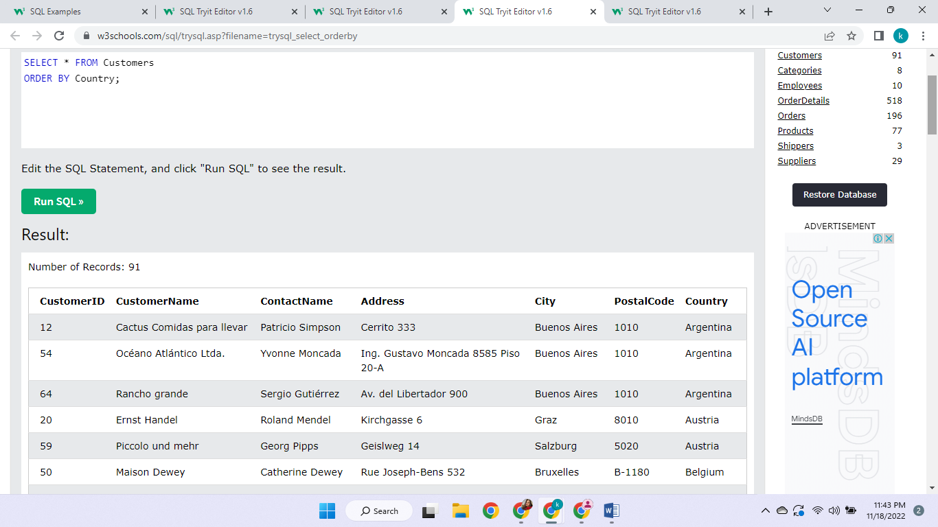

12. This is listing the records in a way that the countries’ name is in descending alphabetical order (Z to A)

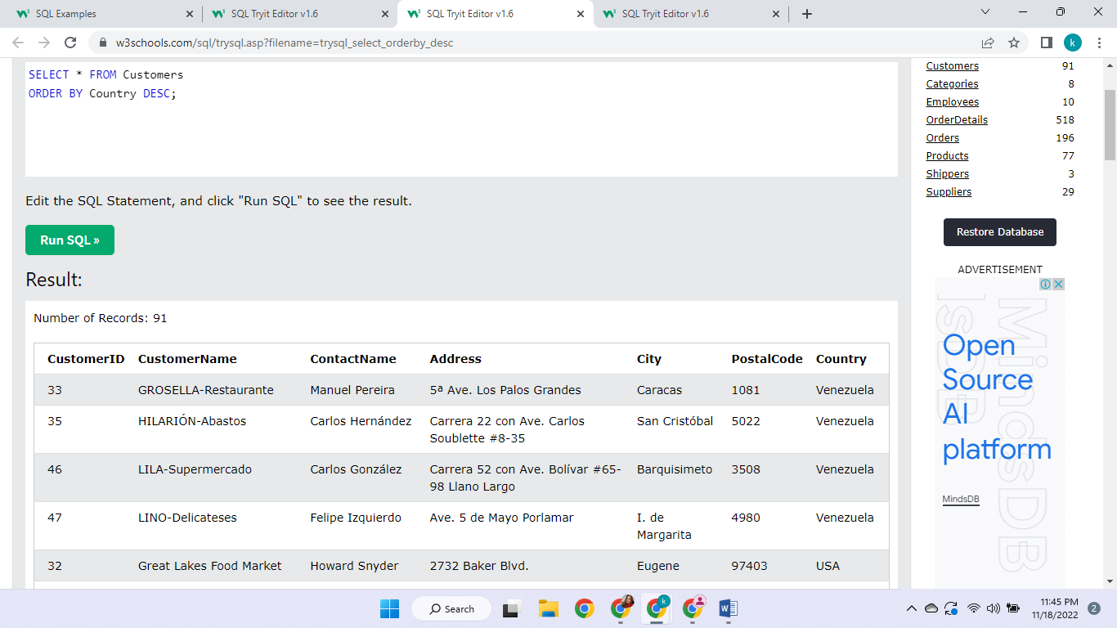

13. This is displaying records first ascending in country then next ascending in customer name

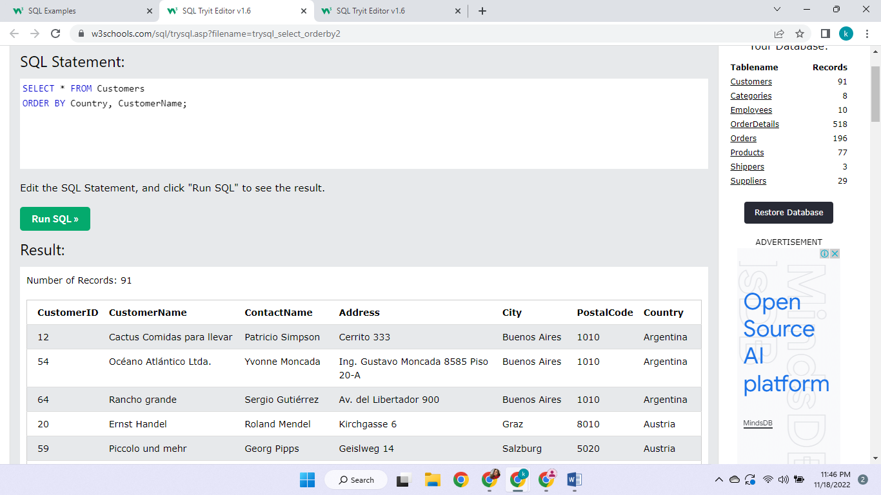

14. By inserting this, it just added another row in our database only in certain columns with these values

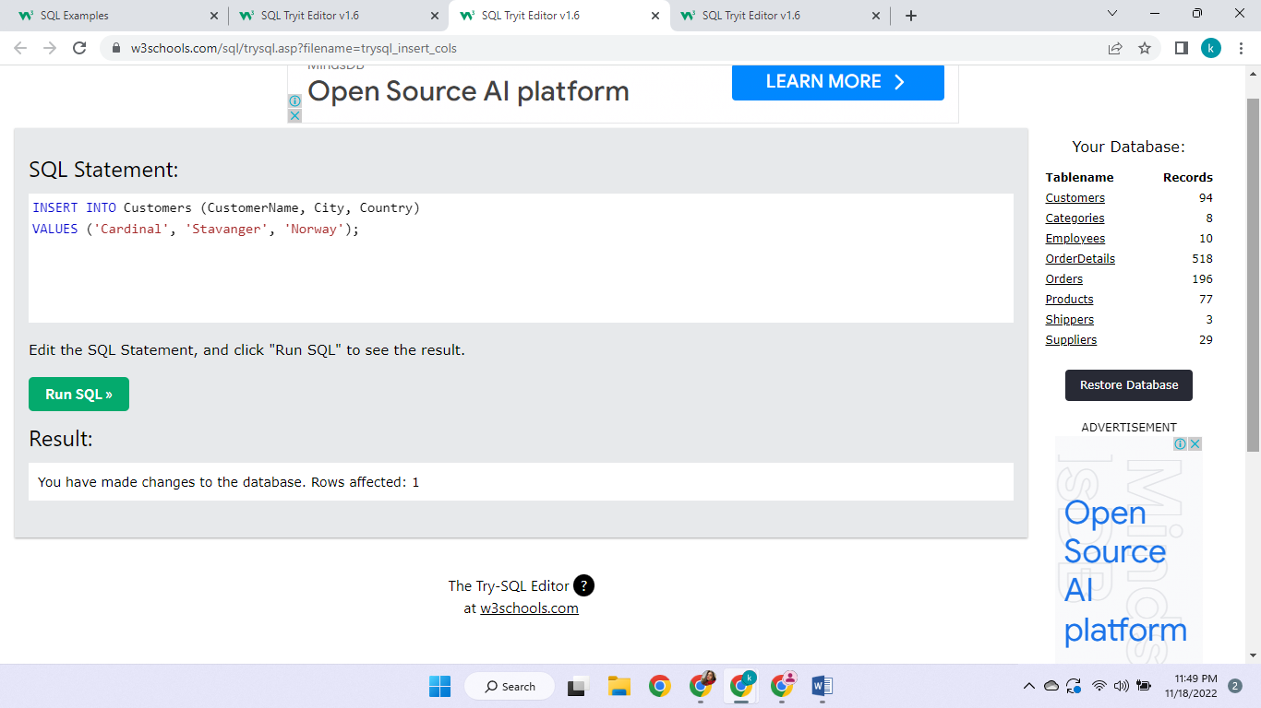

15. This inserts and fills up a complete row in all the columns

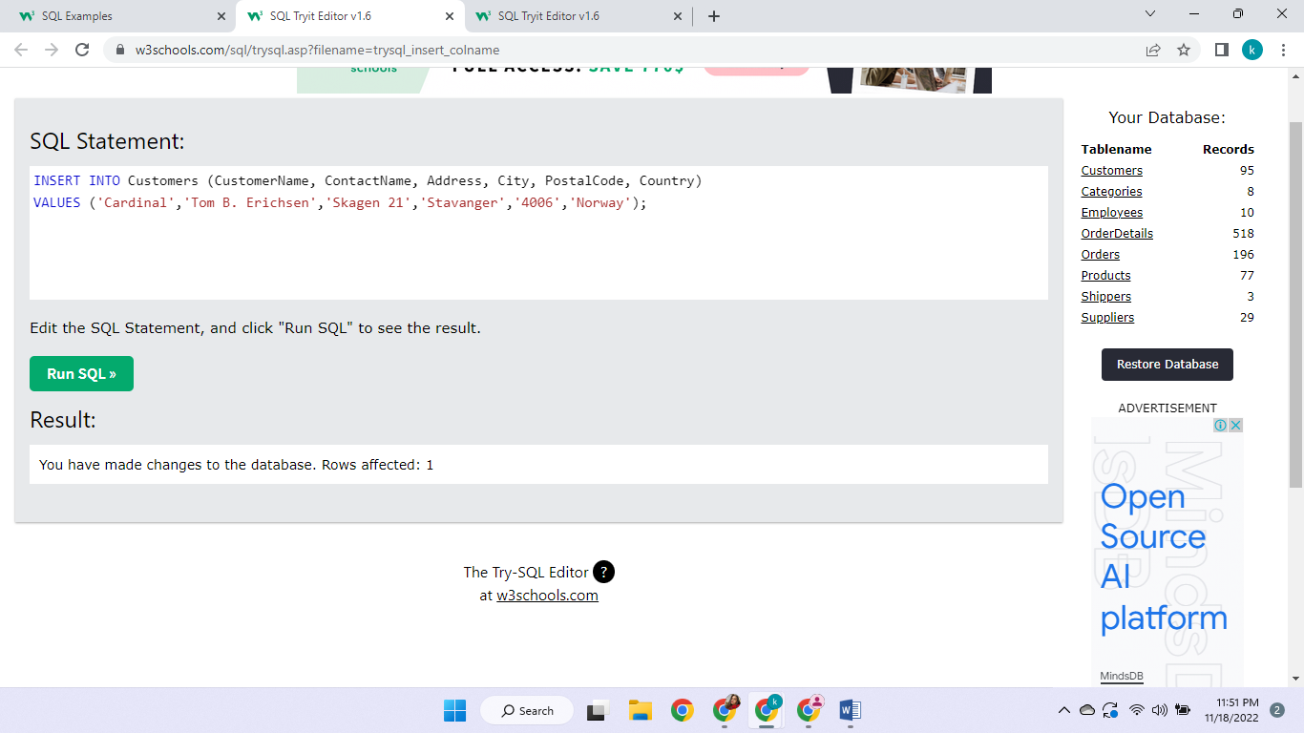

16. This is displaying the certain selected columns where the address value is empty

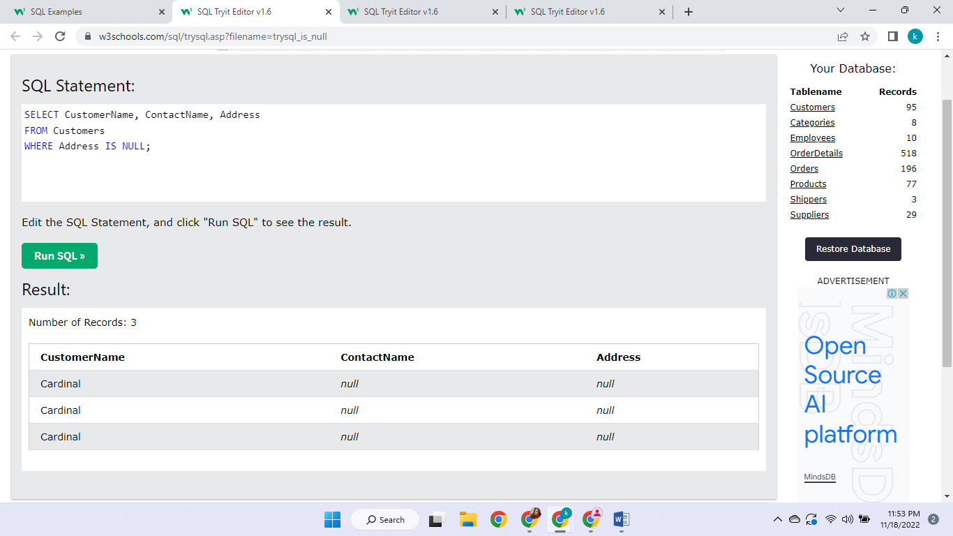

17. This is displaying the certain selected columns where the address value is not empty

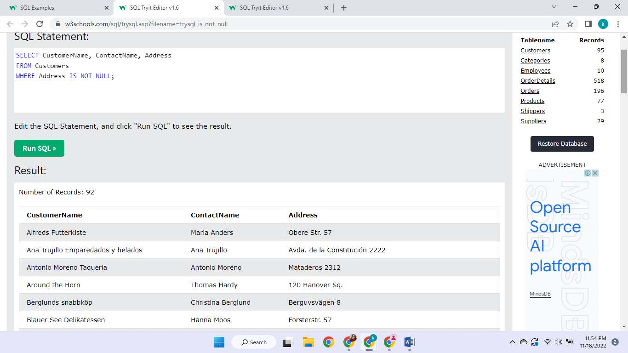

18. This is changing/updating the values in the previous record where the customer id is 1 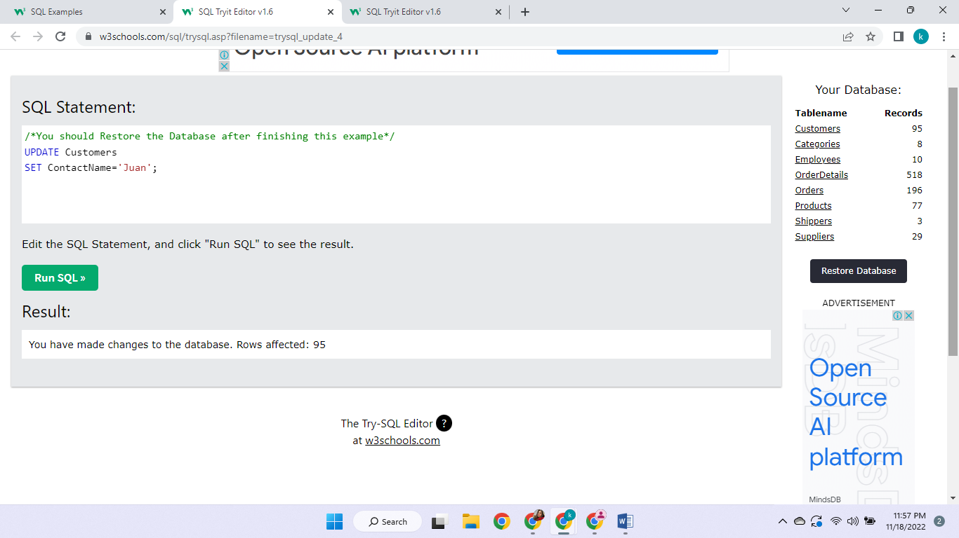

19. This is updating the entire database, changing every contact name



20. This deletes all the customer entries

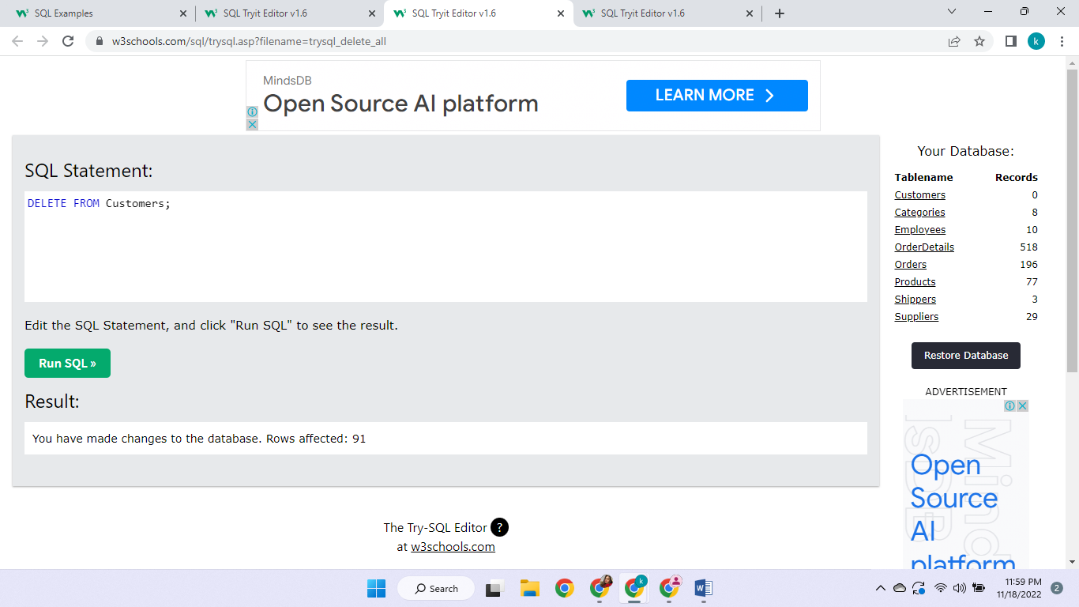

21. This deletes that entry where the name is alfreds

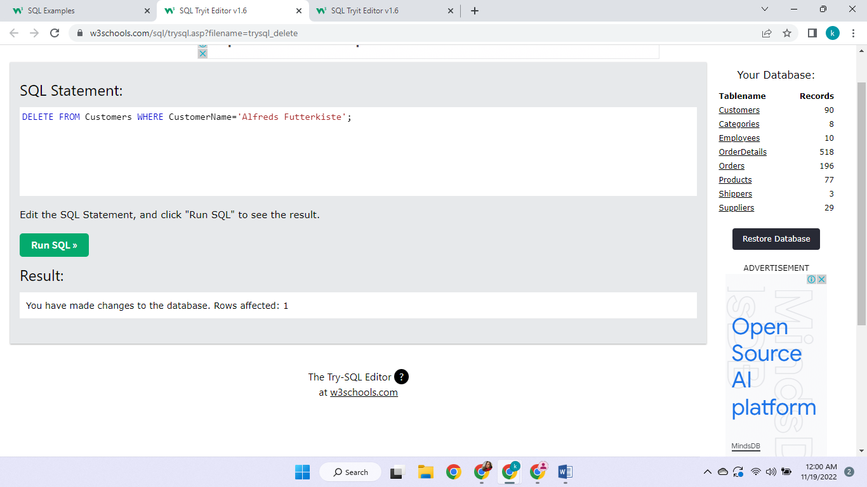

22. This selects the top 3 entries according to customer id

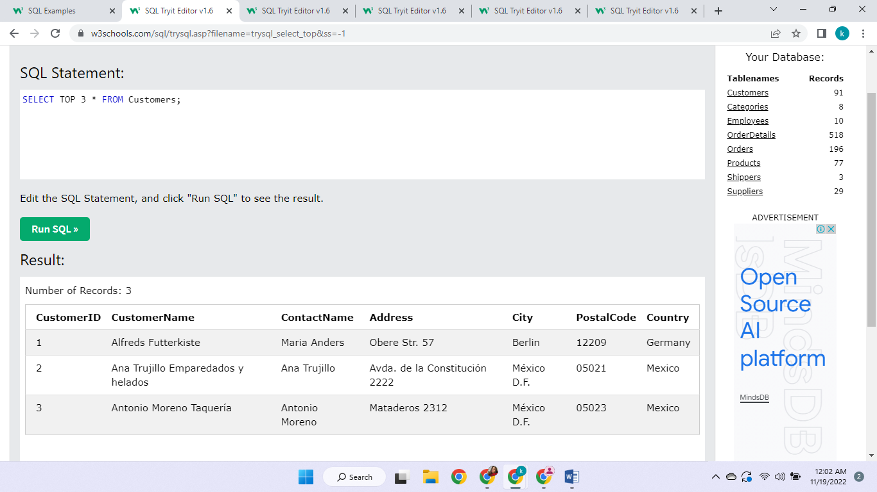

23. This is showing the all the top rows ; top half of the entire database

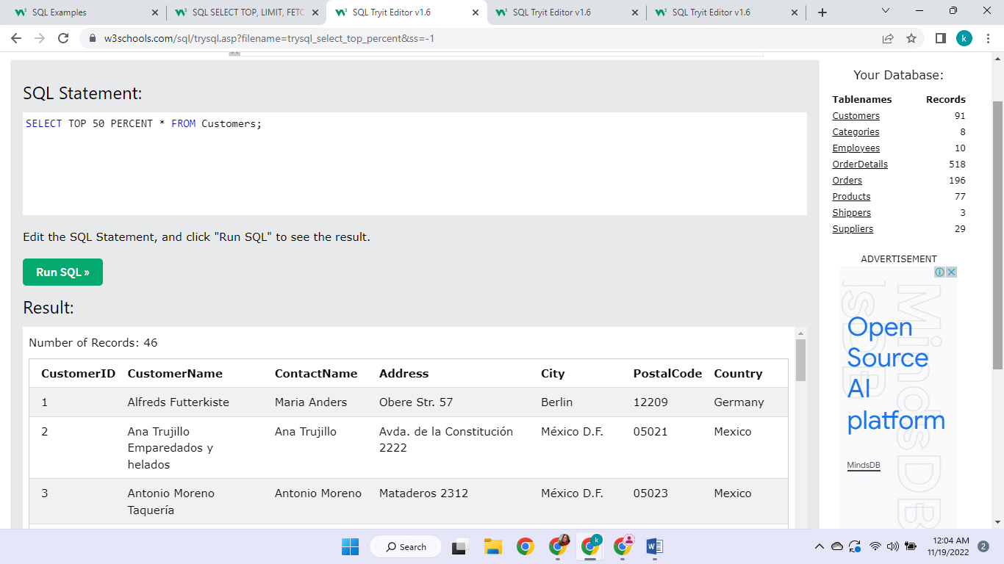

24. This is showing top 3 values of the condition that country is germany

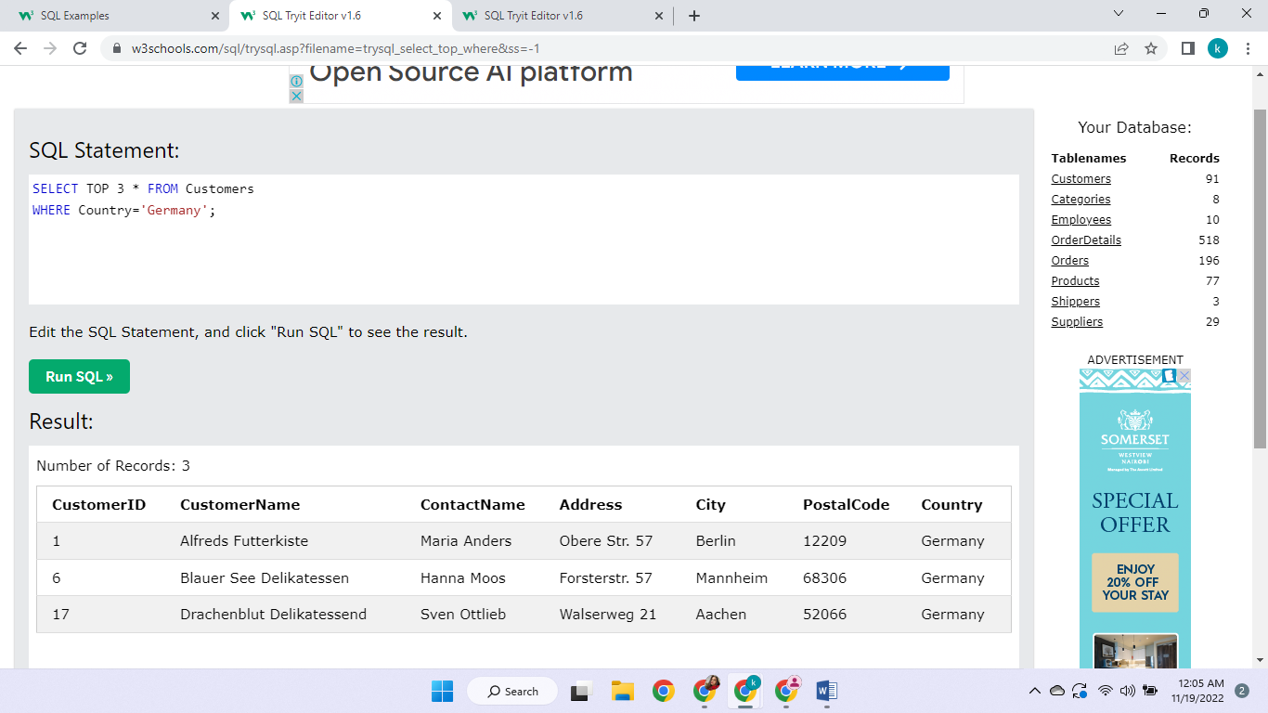

25. This is displaying the entry that has the smallest price in the database

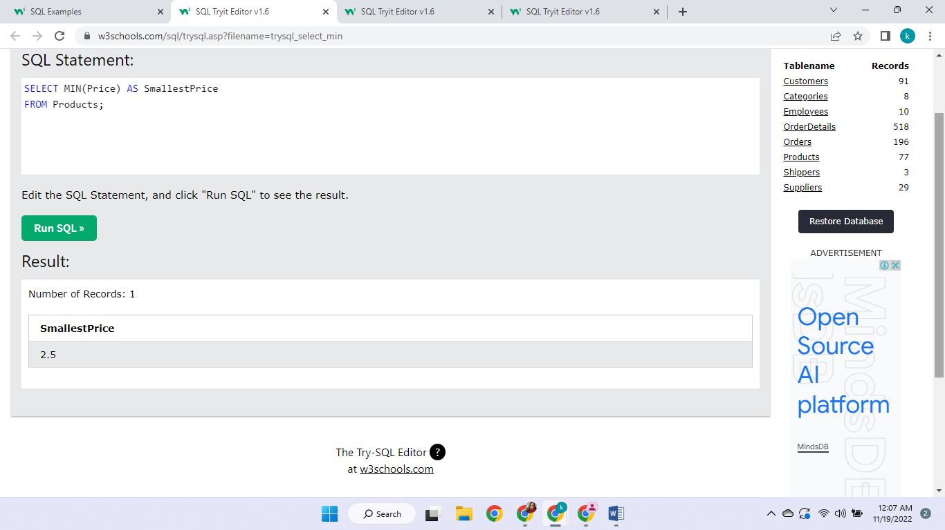

26. This is displaying the entry that has the highest price in the database

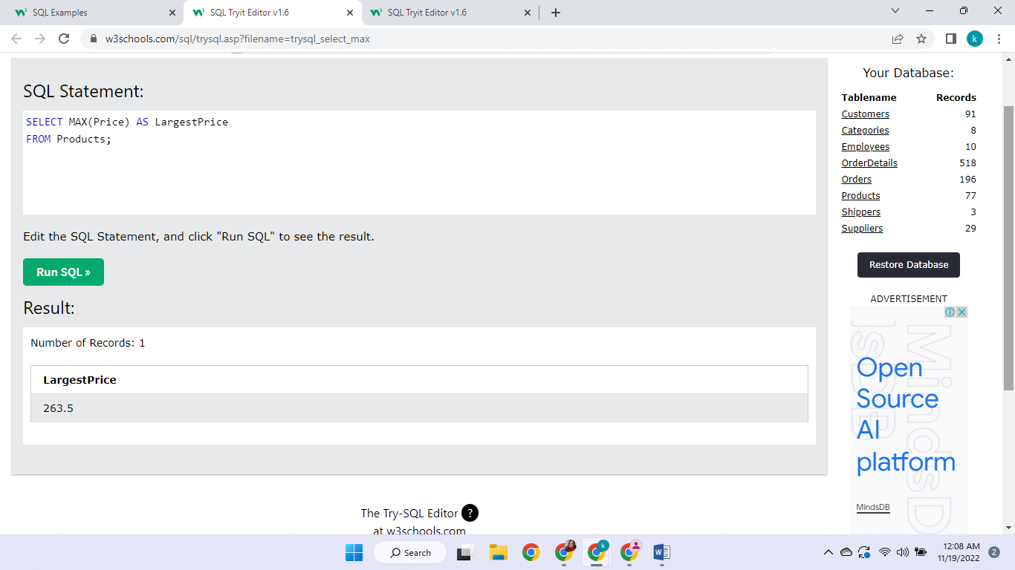

27. This displays how many records are in the database

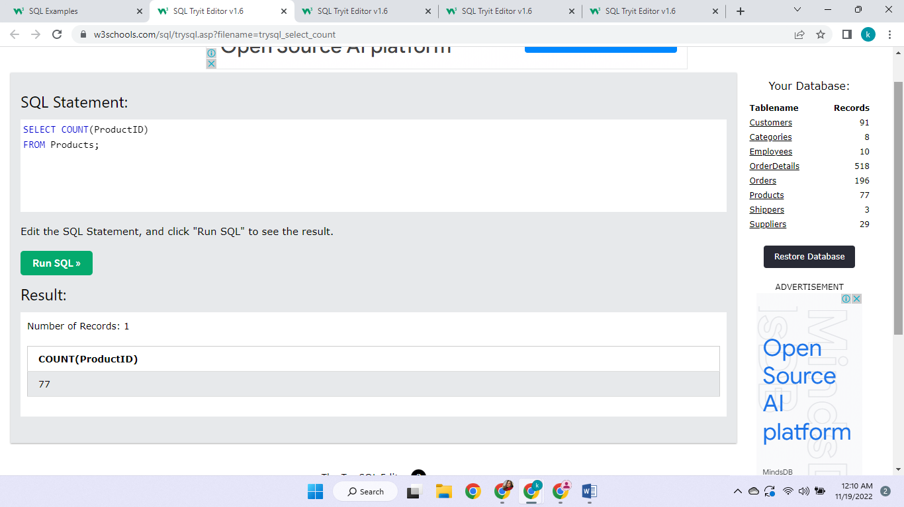

28. This sums up and averages up the price column

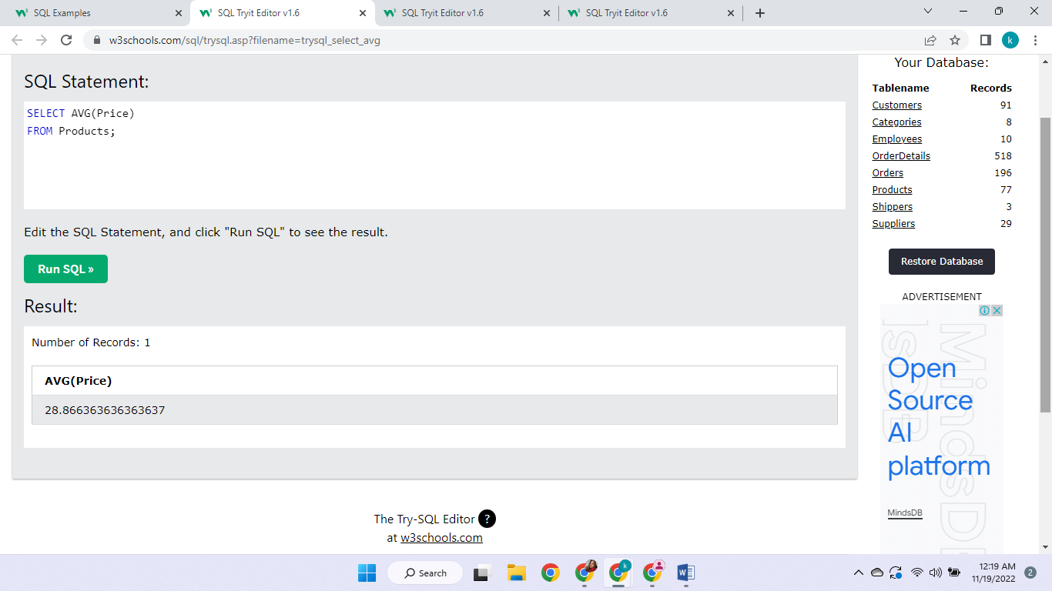

29. This adds up all the values from quantity column

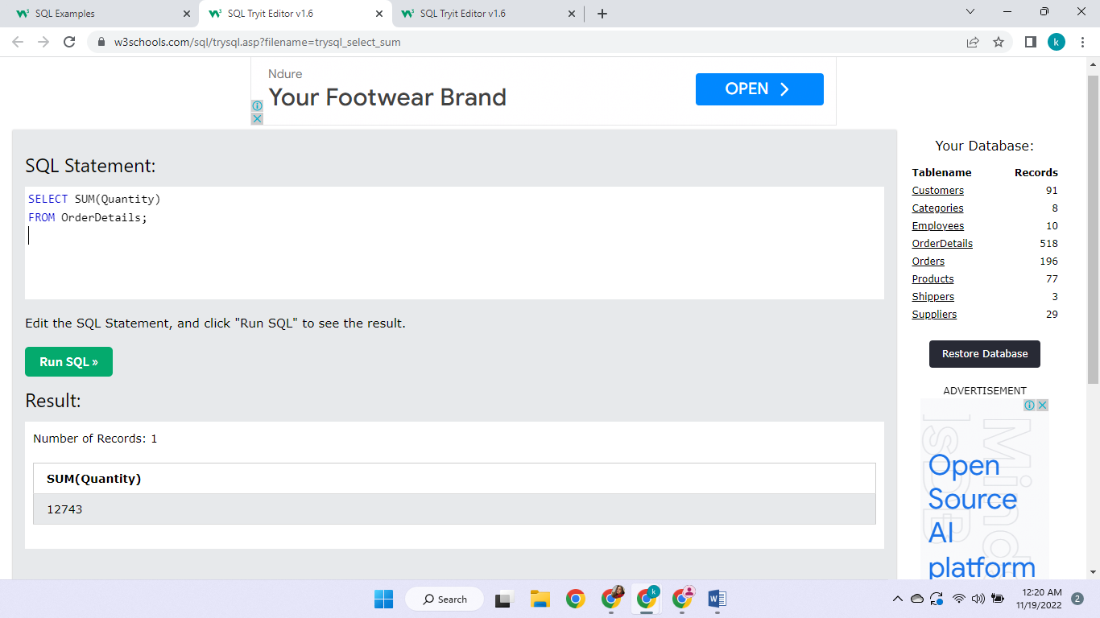

30. List entries in which the customer name starts with a

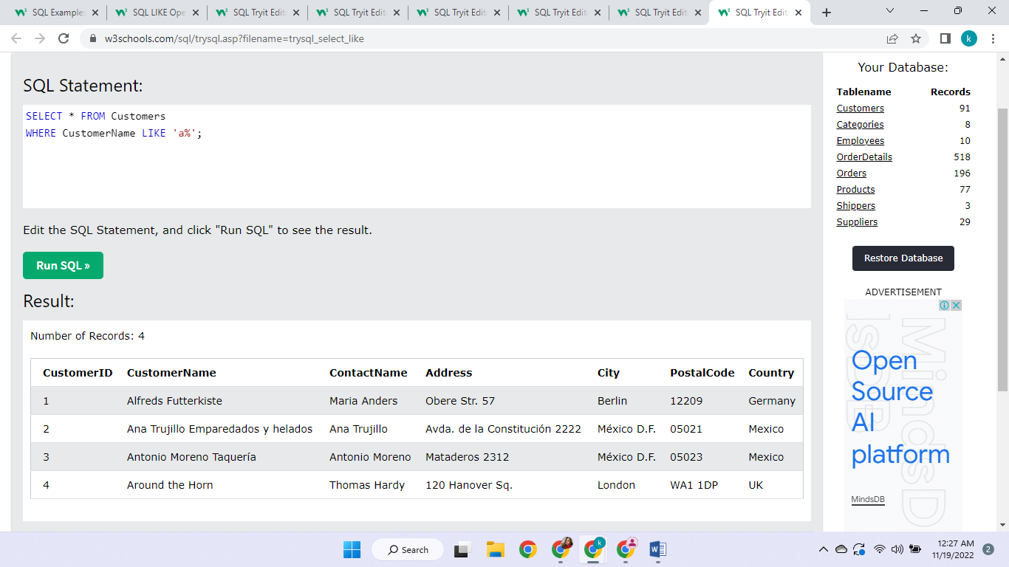

31. List entries in which the customer name ends with a

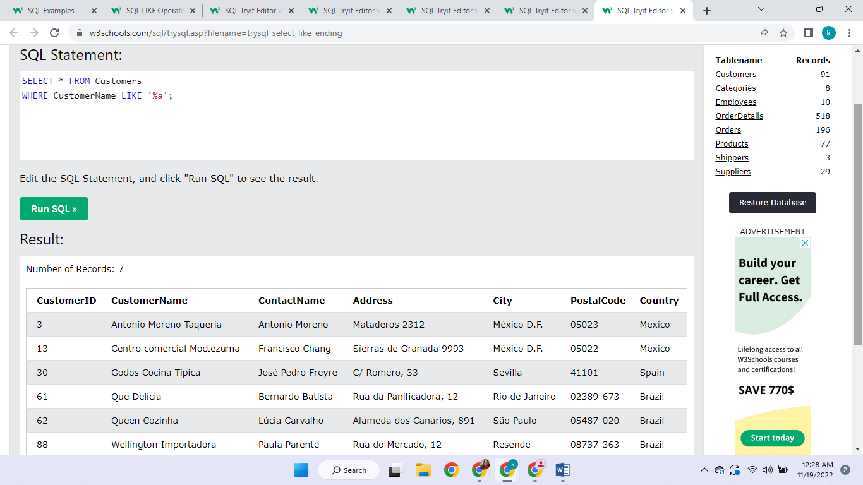

32. This will find all values that have ‘or’ in any position of the customer name 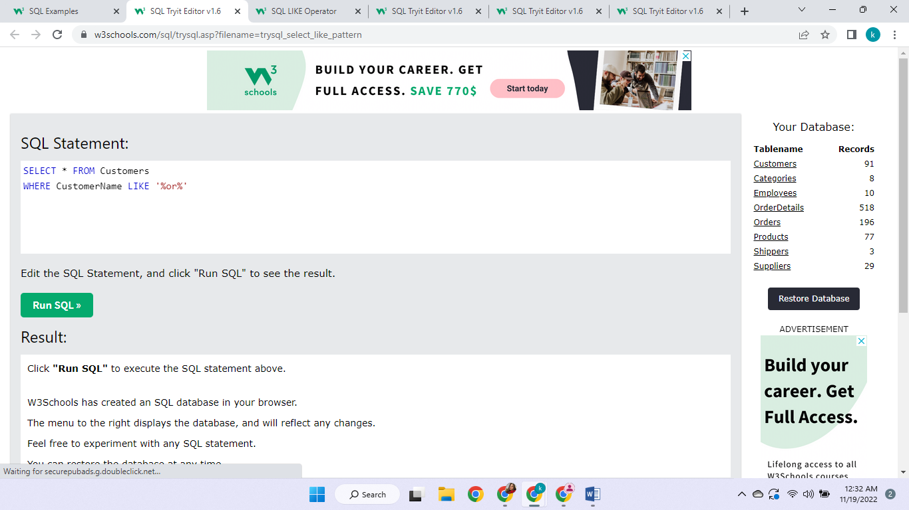

33. This will find all values that have ‘r’ in second position of the customer name

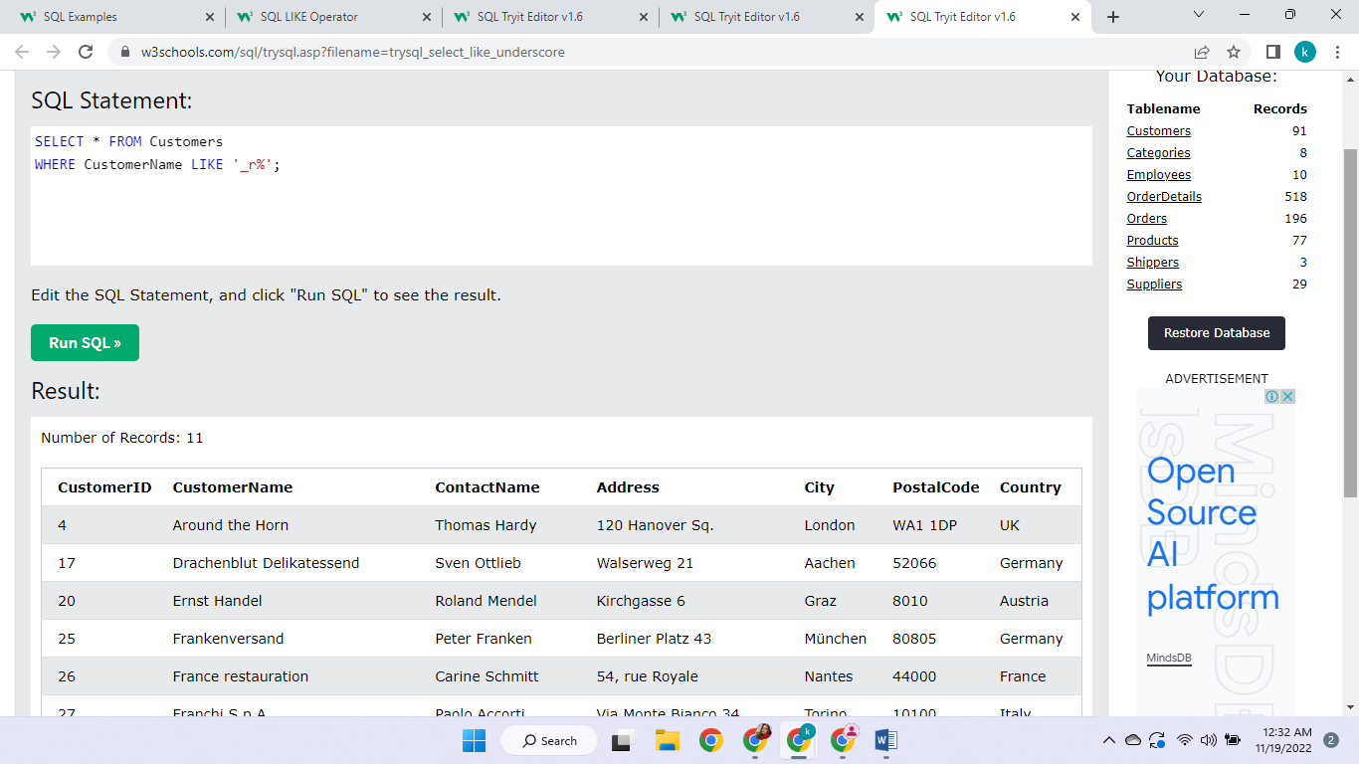

34. In this the contact name should start with a and end with o

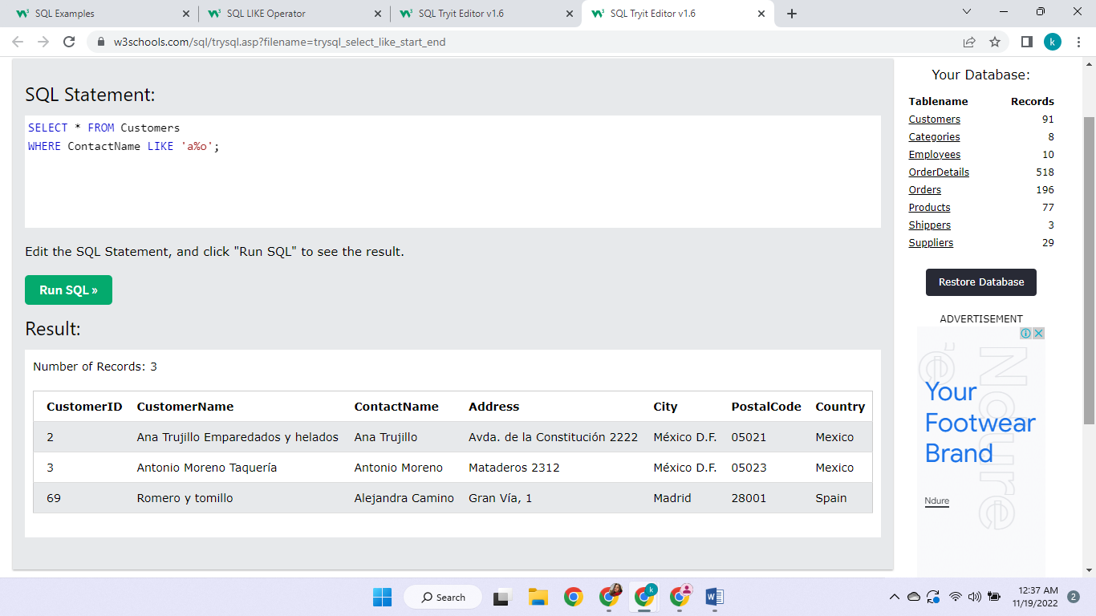

35. This selects all the rows in which the customer name does not start with a

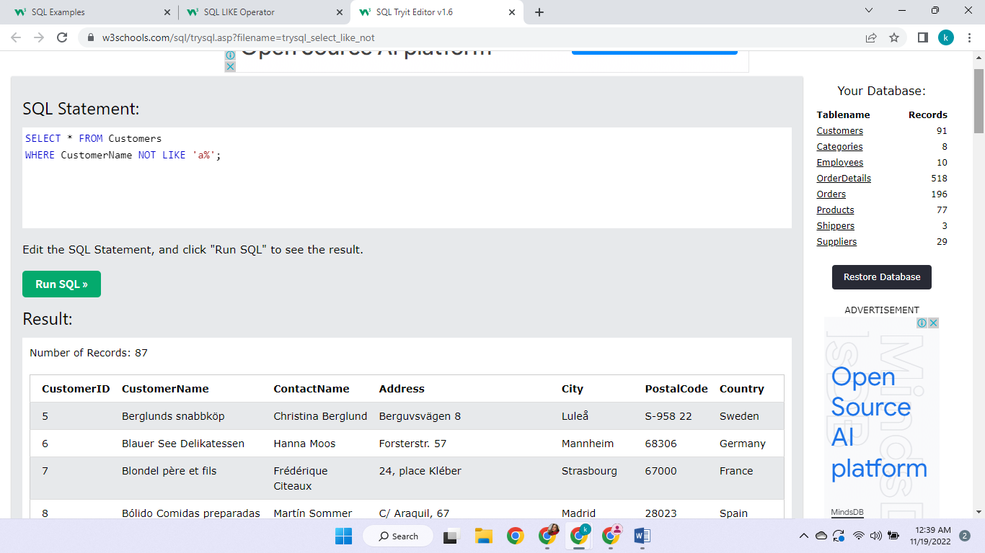

36. This selects all the rows in which the city name starts with ‘ber’

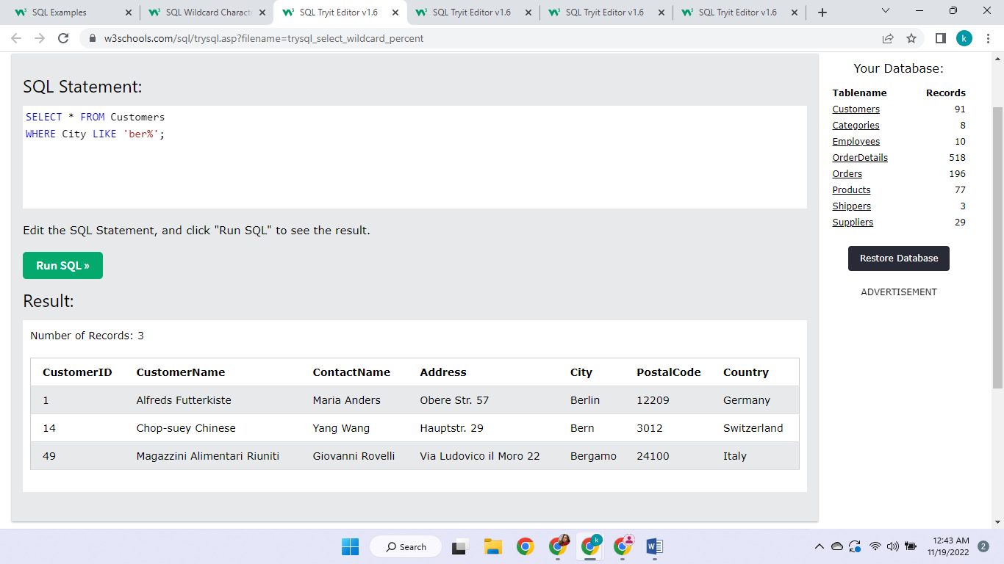

37. displays the entries where city ends in ‘ondon’

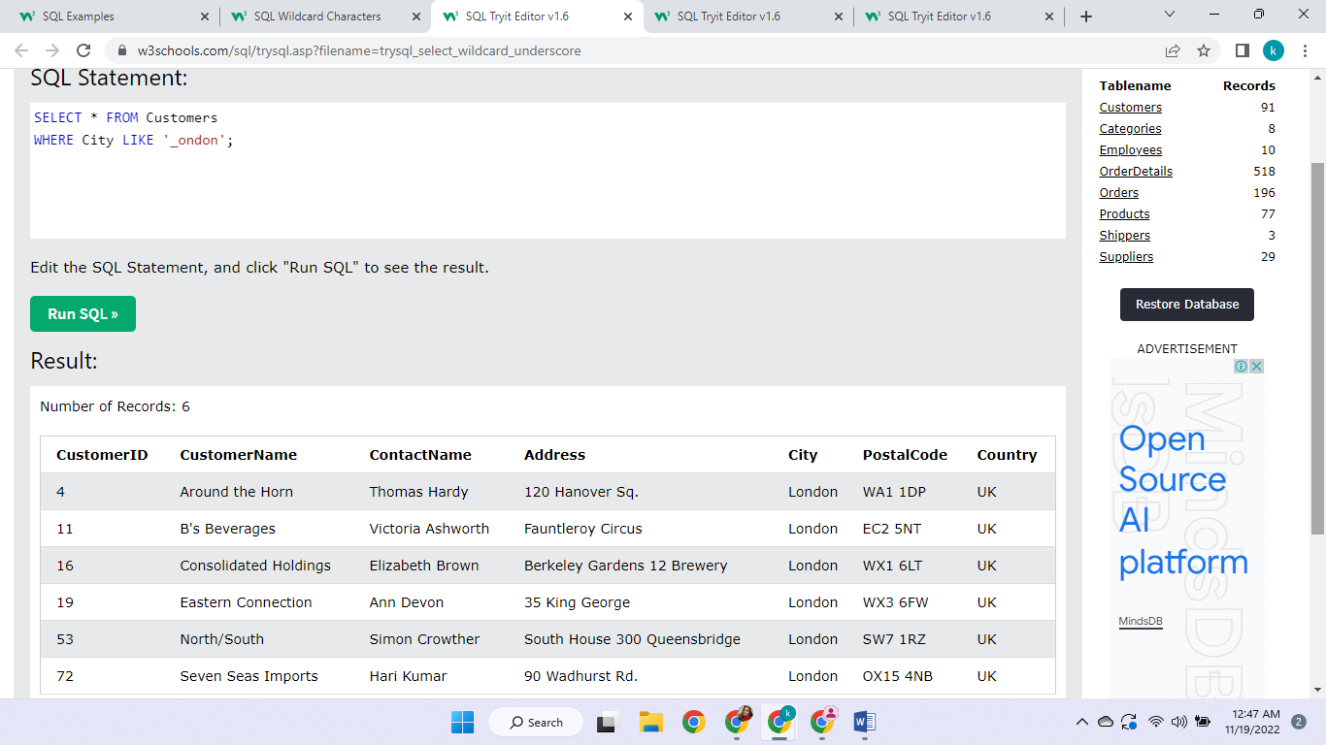

38. displays the entries where city starts with b, s or p

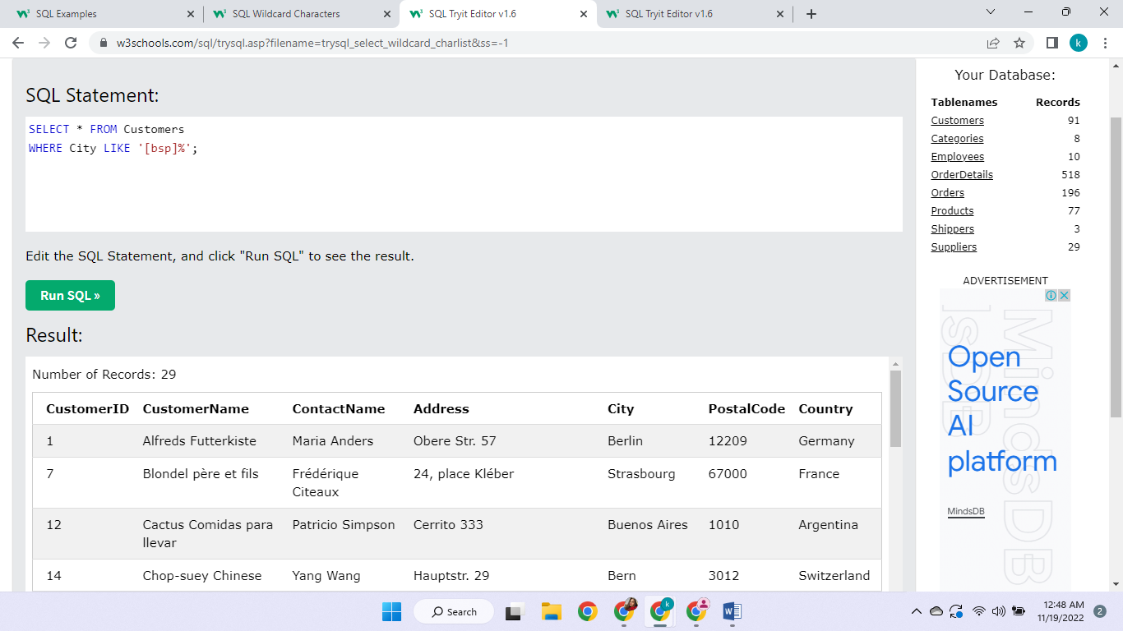

39. displays all the entries except in where the city starts with b, s or p

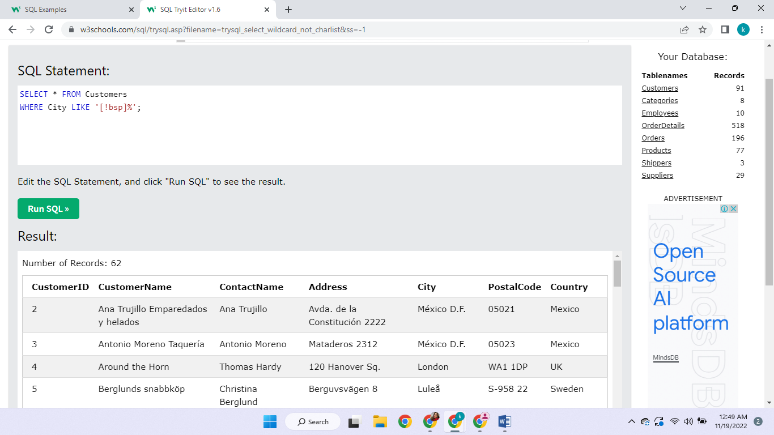

40. This acts like a OR statement so this one shows all entries in which country is germany or France or uk. We can select multiple or choices

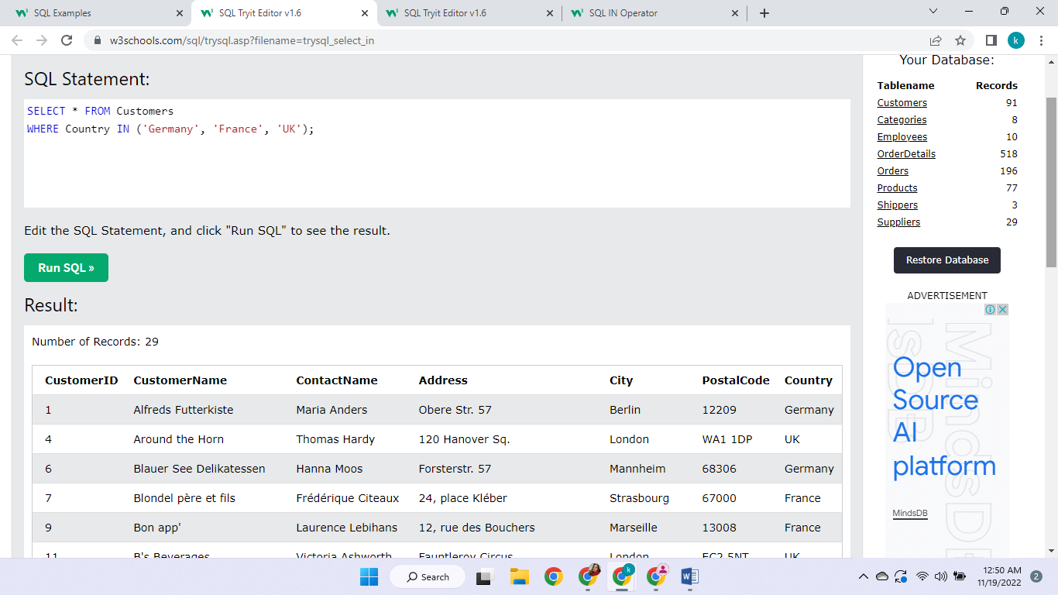

41 . This acts like an opposite of OR statement so this one shows all entries except in which country is germany or France or uk.

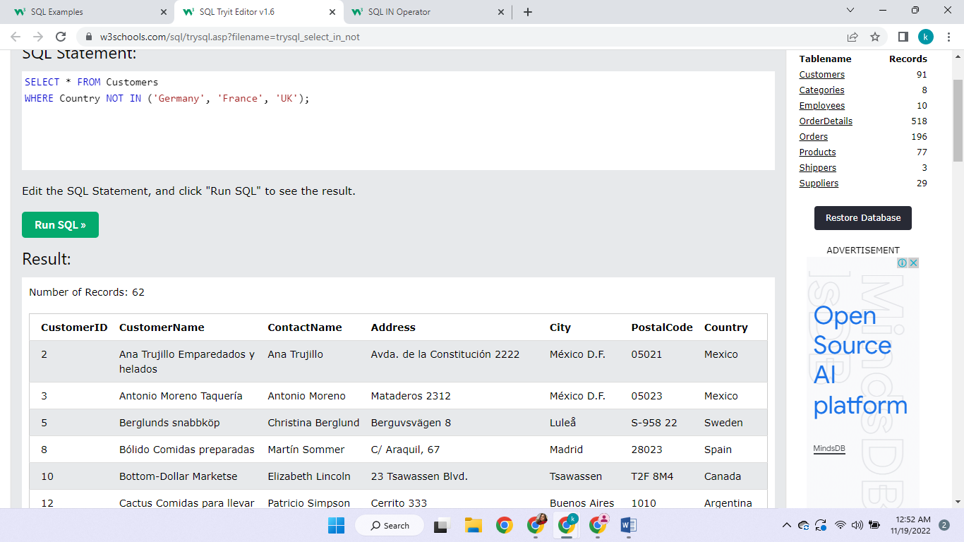

42. This is giving a price range to the price column that it should be from 10 to 20

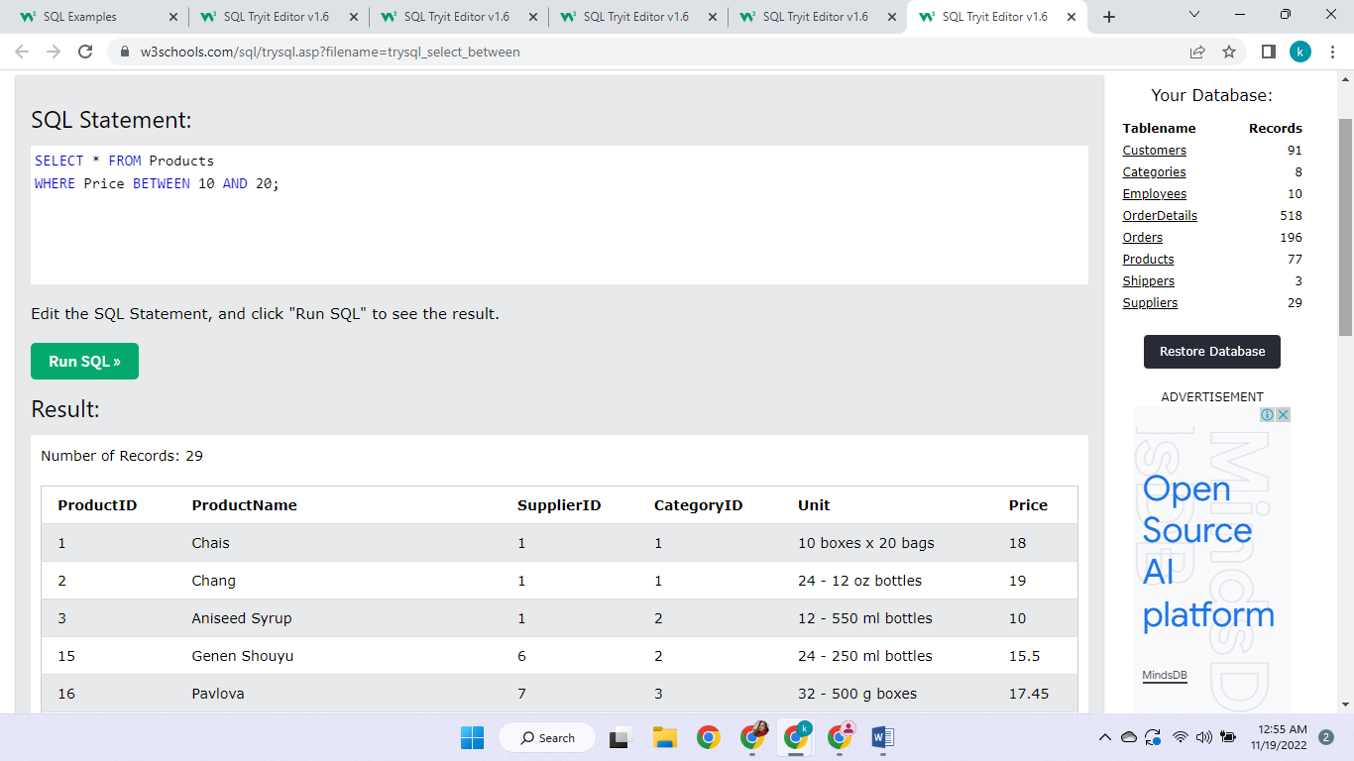

43. This is excluding the range 10 to 20 from the price column

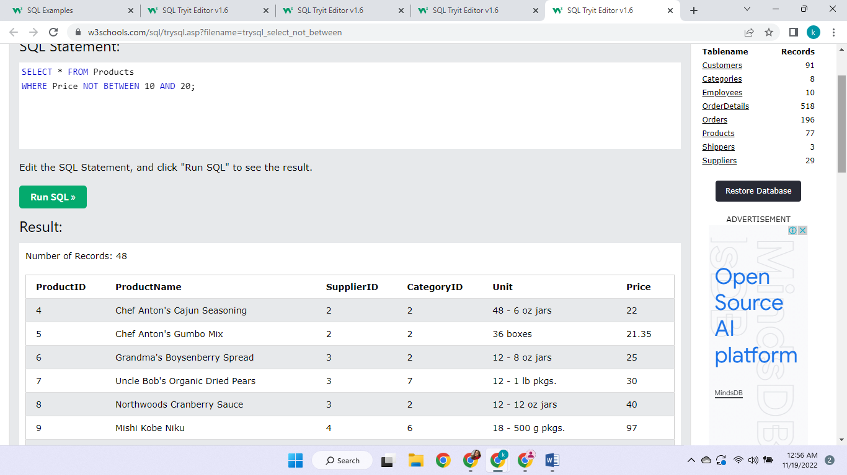

44. This changes the field name to the one mentioned

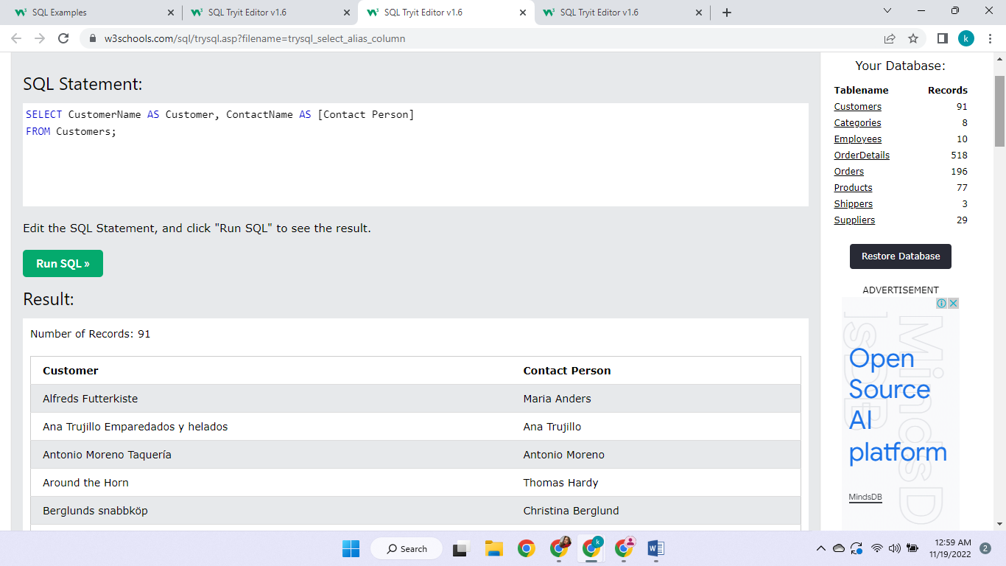

45. This is showing fields between two tables. Orders and Customers. It is displaying two fields

And matching customer ids which are present in both table.

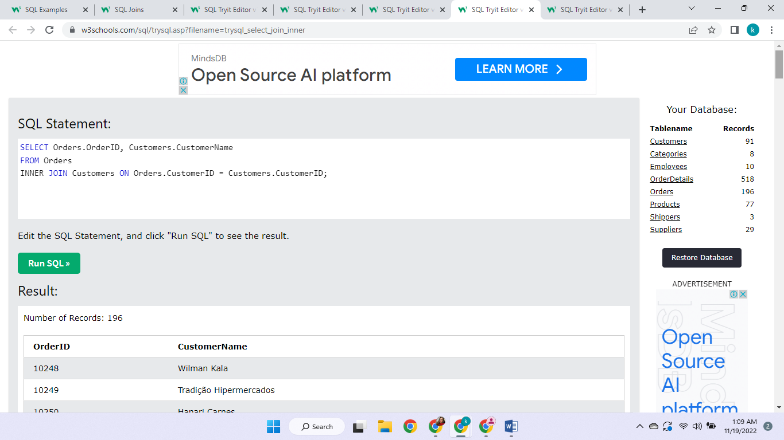

46. This is combining two fields of two tables and displaying them in ascending order only once

So it shows all different values

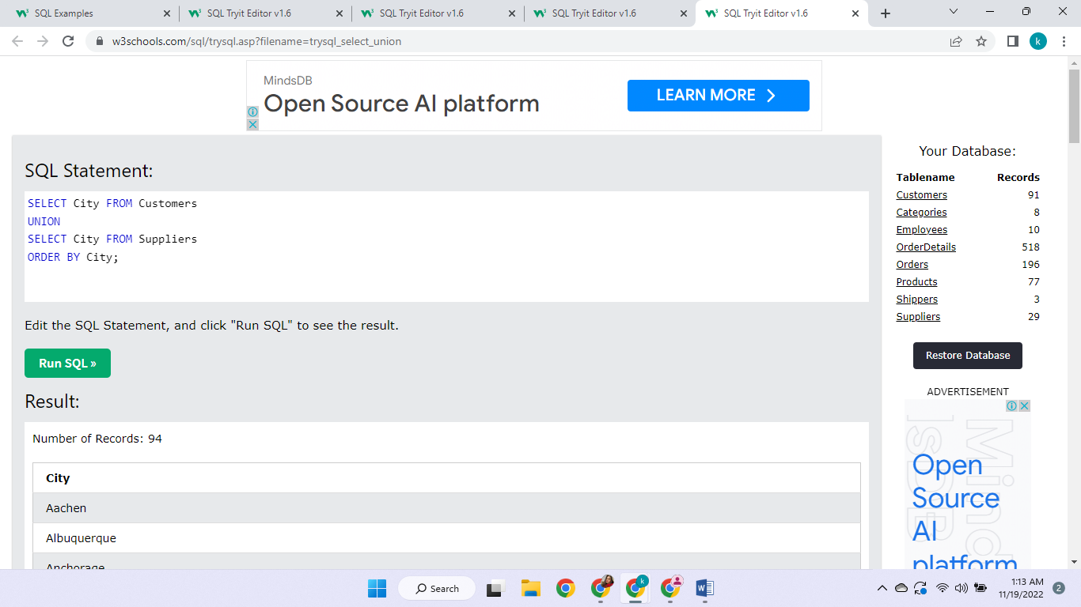

47. This is combining two fields of two tables and displaying them in ascending order

So it shows all values with repetition

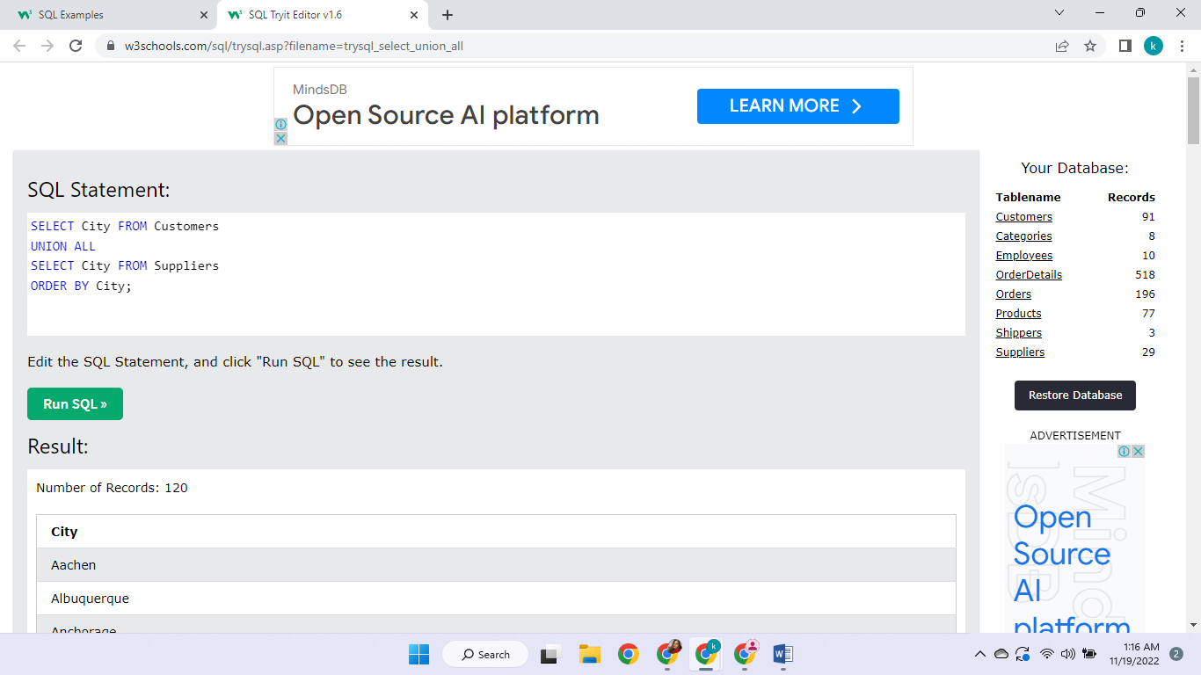

48.

This is grouping all the customers and summing up them according to the country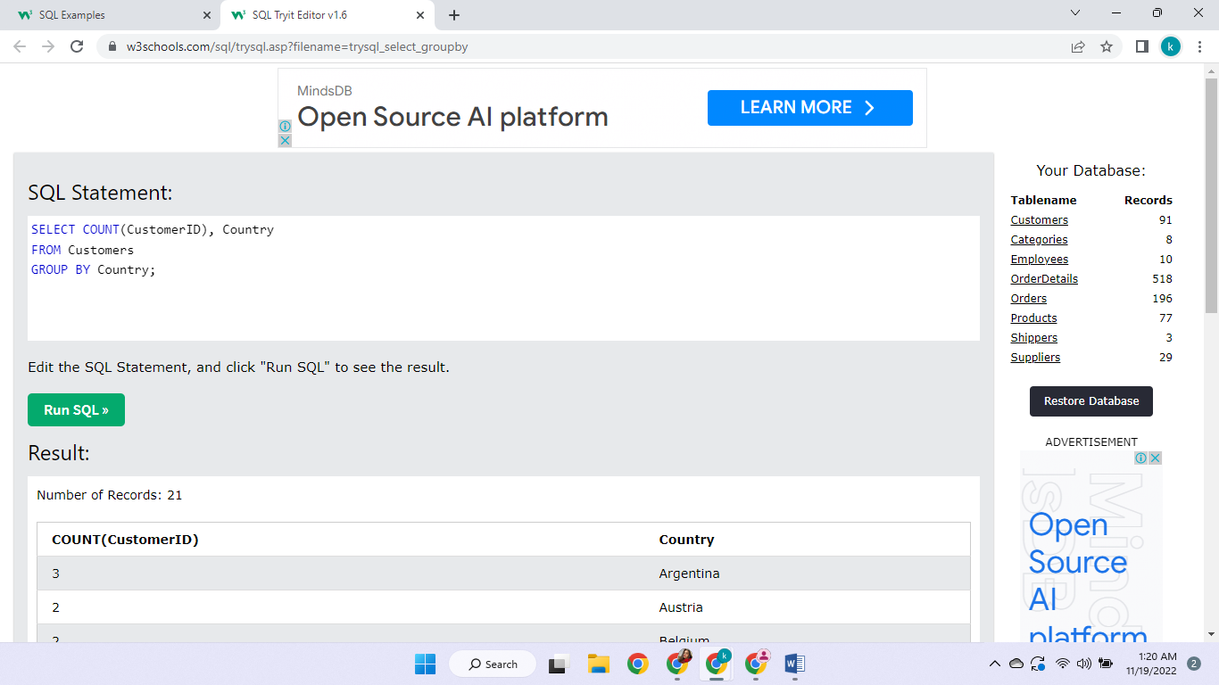

49. This is combined grouping and having

Same as grouping but it will only display is the count is above 5

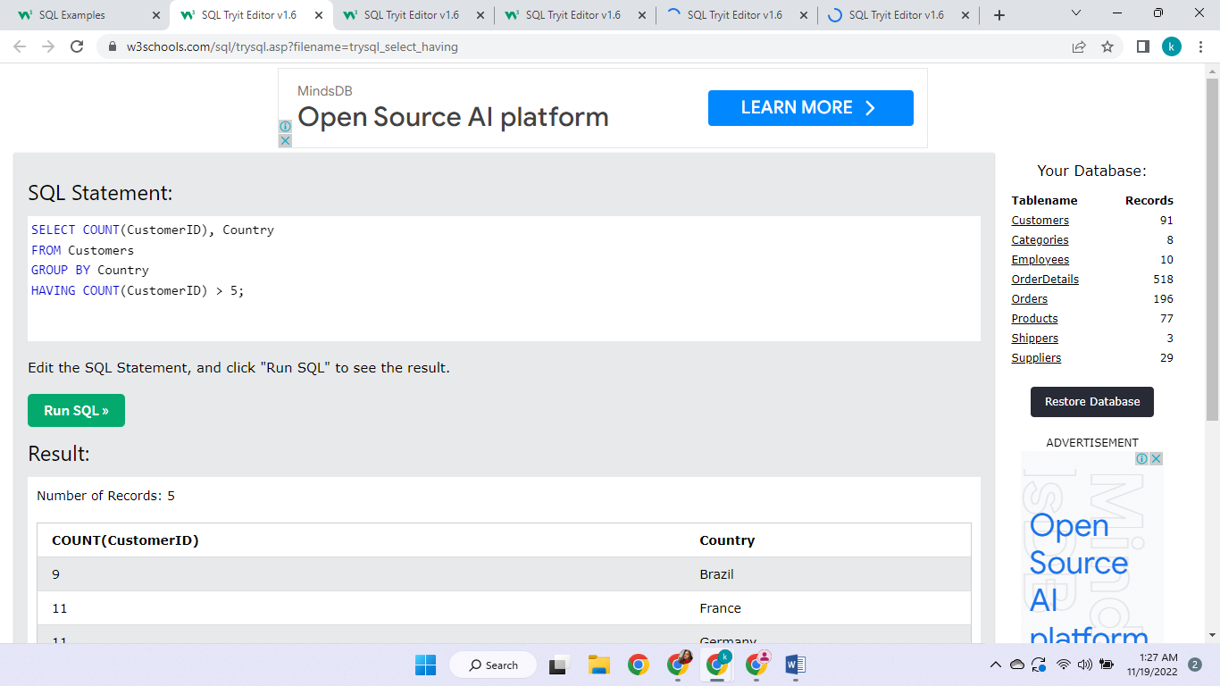

50. This tests for existence of the records where all the conditions are met

